*743

**LABEL**

<label id="lb1">Profile Type:&nbsp;&nbsp;</label>

<input **type**=”**text**”><br>

<input **type**=”**radio**”><br>

<input **type**=”**checkbox**”><br>

<textarea></textarea>

**DATE PICKER**

<input type="date" id ="aa" />

**BOTON**

<input **type**=”**button**” value = “**go!**”><br>

<input **type**=”**submit**”>

<input id='BtnUnlock2' type="button" onclick="Check2(); return false;"

style="width:83px;height:31px; color: black; font: bold 17px Arial" value='UNLOCK'/>





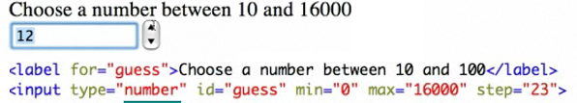

<input type="number" id="minutos" min="0" max="6" onchange="SetMinutos();"/>

function SetMinutos() {

var valor = document.getElementById("minutos").value;

document.getElementById('hdMinutos').value = valor;

return false;

}

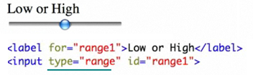

**File Upload**



**HIDDEN FIELD**

<input type="**hidden**" id="Language" value="English">

$("#Language").val("Spanish,English,French");

var listaStr = $('#Language').val();

var Lista = eval(listaStr);

var temp = new Array();

temp = listaStr.split(",");

alert(temp[1]);